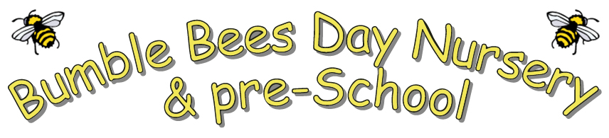

No smoking policy
At Bumble Bees, we are committed to promoting children’s health and wellbeing. This is of the upmost importance for the nursery. Smoking has proved to be a health risk and therefore in accordance with legislation, the nursery operates a strict no smoking policy within the area of the building and the grounds it uses.
It is illegal to smoke in enclosed public places. All persons must abstain from smoking while on the premises. This applies to staff, students, parents, carers, contractors and any other visitors to the premises.
Staff accompanying children outside the nursery are not permitted to smoke. We also request that parents accompanying nursery children on outings, refrain from smoking whilst caring for the children.
Staff must not smoke whilst on duty or wearing nursery uniform as it is essential that staff are positive role models to children and promote a healthy lifestyle. If staff choose to smoke during breaks, they are asked to change into their own clothing and smoke away from the main entrance.
We respect that smoking is a personal choice although as an organisation we support healthy lifestyles. We aim to help staff and parents stop smoking by:
- providing fact sheets and leaflets
- providing information of local help groups providing details of the NHS quit smoking helpline WWW dot smoke free dot nhs.uk
- offering information regarding products that are available to help stop smoking.
- offering in-house support
This policy also applies to electronic cigarettes.
Policy updated February 2024.

