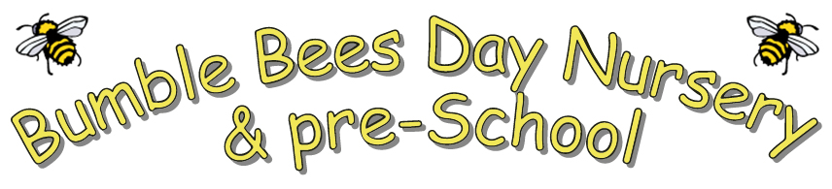
Use of dummies in Nursery
Bumble Bees recognise that a dummy can be a source of comfort for a child who is settling and/or upset, and that it may often form part of a child’s sleep routine.
We also recognise that overuse of dummies may affect a child’s language development as it may restrict the mouth movements needed for speech. As babies get older, they need to learn to move their mouths in different ways, to smile, to blow bubbles, to make sounds, to chew food and eventually to talk. As babies move their mouths and experiment with babbling sounds, they are learning to make the quick mouth movements needed for speech. The more practice they get the better their awareness of their mouths and the better their speech will be.
Bumble Bees will:
- Discuss the use of dummies with parents as part of babies’ individual care plans
- Only allow dummies for comfort if a child is really upset (for example, if they are new to the setting or going through a transition) and/or as part of their sleep routine
- Store dummies in individual hygienic dummy boxes labelled with the child’s name to prevent cross-contamination with other children
- Immediately clean or sterilise any dummy or bottle that falls on the floor or is picked up by another child.
- Dummies will be disposed of if they become damaged and/or when they are required to be disposed of.

When discouraging the dummy, staff will:
- Make each child aware of a designated place where the dummy is stored
- Comfort the child and, if appropriate, explain in a sensitive manner why they do not need their dummy
- Distract the child with other activities and ensure they are settled before leaving them to play
- Offer other methods of comfort such as a toy, teddy or blanket
- Explain to the child they can have their dummy when they go home or at sleep time.

We will also offer support and advice to parents to discourage dummy use during waking hours at home and suggest ways which the child can be weaned off their dummy through books and stories (when appropriate).

Policy adopted May 2025

